Alenjandro Sanz Garotte

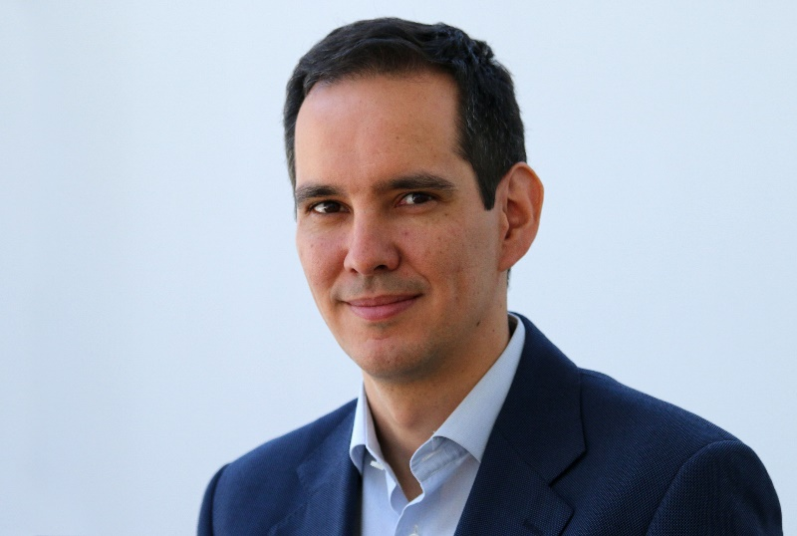

Alejandro is the Head of Tunnelling at Gravity Engineering, Dragados Group’s engineering company. He is also part of ITA Working Group 17 Long Tunnels at Great Depth representing Spain. He has significant experience in the design and construction of tunnels, including the construction of TBM-bored, sequential excavation methods and drill and blast excavated tunnels. Alejandro has wide ranging expertise gained from delivery of world class projects, including most recently REM Tunnel in Montreal, Hampton Roads Bridge Tunnel in Virginia, Los Angeles Outfall Effluent, Lima Metro and Bank Station Capacity Upgrade in London.

