Magali SCHIVRE

CO-FOUNDER, PARTNER
INCAS Partners

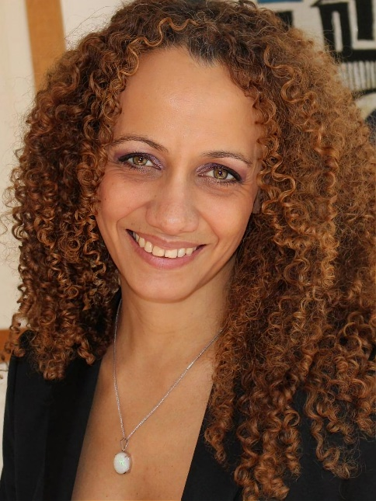

Magali Schivre is a senior tunneling and geotechnical engineer, with 20 years of experience in underground works (railways, roads, sewage), acquired in VINCI, SNCF, and SYSTRA. For 5 years now, Magali has been co-founder and partner of INCAS Partners, an independent company that provides Technical & Contractual consulting services for decision-makers and the main actors of underground infrastructural projects, in France and abroad.
Magali has worked on several ambitious project, like High-Speed Links, the Lyon-Turin Project, or doubling the Frejus Road Tunnel, or the EOLE extension, and the Grand Paris Express Project, acting as well on the engineering side or as an Owner advisor. Acquiring experience from the early stage of design to the construction phase, her experience encompasses major aspects of underground projects, and their contractualization. As INCAS Partners, she intervenes for Owners, Engineering Companies, and Contractors. When intervening from the Owners’ side she has been frequently in charge of challenging major projects seeking the contractual and technical robustness with the aim of achieving the Owner’s objectives (e.g., Lyon Metro, EOLE Project, Extension of Paris Metro Line 14 to southbound).
Magali is co-animator of the working group GT4 « Mechanized Tunnelling» of the AFTES (French Association of Tunnels and Underground Space) since 2013, and she is now the animator of the working group WG17 « Long tunnels at greath depth » of ITA-AITES, after joining this WG in 2006.

